# MSc in Data Analytics

MSC_DA_InterGr_CA2

Bovine Data – Agriculture Analysis

Author: Alan Devane

e-mail: sba22166@student.cct.ie

Student ID: sba22166

## Abstract

*This report details the steps undertaken for C2. In this assignment we were tasked with analysing Ireland’s agriculture data and comparing it to other countries. We were required to analyse and make recommendations for the sector based on our findings.*

*Coming from a small Dairy farming background, I chose data related to Dairy Cows, which included Milk Prices, Dairy Cow populations, Total Bovine Population and Meat from Bovine sources.*

*In this report I attempted to clean the data aquired, refactor it to be in a usuable format, make assumptions based on the data using tables, plots and figures, and forecast for the future.*

**Introduction**

For this assignment we were given the freedom to use and extract data from any data source with regards to the agriculture sector in the world. There is a vast amount of data available to us from websites all across the world. After checking various sources, I came across Eurostat ([https://ec.europa.eu/eurostat/](https://ec.europa.eu/eurostat/web/main/home). Eurostat is an official European Union website. According to its website *“The Eurostat database always contains the****latest version of the datasets****, meaning that there is no versioning or documentation of past versions of the data.”* (Eurostat, 2023)

Dairy Farming and Bovine meat export are a massive part of Ireland’s Agriculture sector. In a Paper produced in 2022, it is deemed as the most important sector in Irelands farming and agri-food sector. (Brock, 2022). With over 100,000 farms in Ireland, and an ever increasing Bovine population, I chose this sector for my analysis.

I aim to forecast and predict many areas of the Dairy farming exports from Ireland, and make recommendations to Irish farmers and business on my findings. There is an abundance of data available to me online for Irelands Dairy sector, and it is clear by the traction these sites are getting that farmers and stakeholders are seeing the benefits of planning, analysing and predicting market trends for the Dairy sector in Ireland and throughout the world.

For this report, I will be discussing three .ipynb files. These three files detail the preparation work on the data, the visualisations created using the prepared data, some statistical analysis on the datasets and machine learning predictions and results. These three files will be included in my upload are names as below:

- DataPrepAndViz.ipynb

- ML.ipynb

- Stats.ipynb

**Materials and Methods**

**Github**

In the project description we were instructed to use a form of version control. For this, I chose Github as my form of version control. Github is a world leading version control servvice, hosted in the cloud. In June 2022, Github reported that it had hit over 83 million developers worldwide. (Wikipedia, 2022)

It is used in the majority of companies worldwide, and is becoming an almost industry standard for software developers and analysts.

For this project I set up a new Github user using my StudentID, this repository is available here at : <https://github.com/sba22166/CCT_MSC_DA_CA2>

I used git via the command line for this project. The commands used were as follows:

* git status : checks the status of the current repository and tracks any changes
* git add – adds any edited files inside the repository to be staged
* git commit – commits staged changes, asks for comment before moving on
* git push – pushing my changes from my local rep to the repo stored at the above link

Here is a sample of a push undertaken during the project.

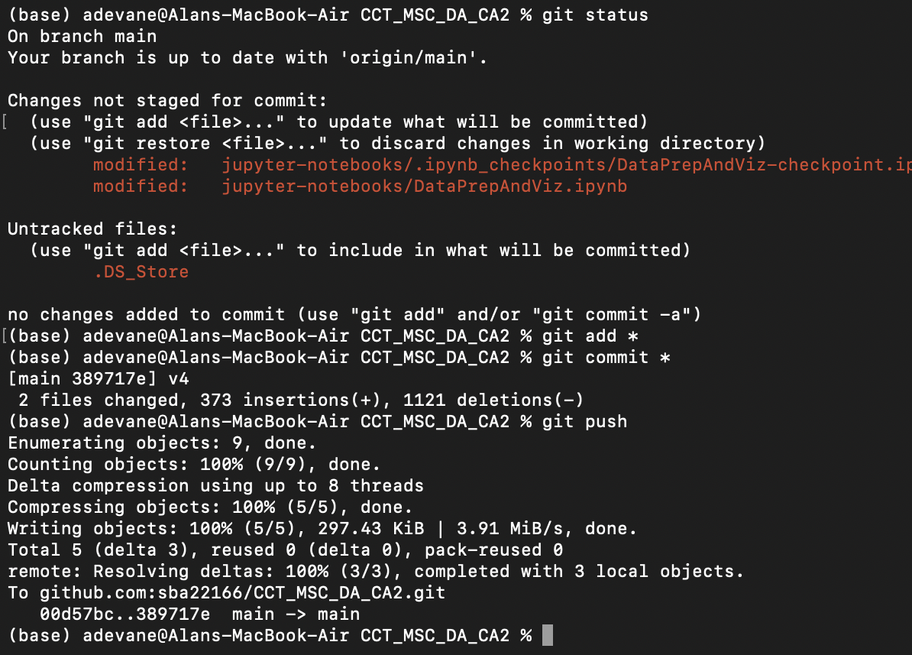

Figure 1- Git Example

**Project Management**

This project followed the CRISP-DM principles throughout the process. CRISP-DM

Stands for The **CR**oss **I**ndustry **S**tandard **P**rocess for **D**ata **M**ining . It is widely used across all Data Science projects. It is broken down into 6 clear steps, and can be applied to alsmot any project. The 6 steps are as follows:

1. Business understanding
2. Data understanding
3. Data preparation
4. Modelling
5. Evaluation
6. Deployment

Business understanding refers to what the Business/Stakeholder is looking to get from the project. This could be weekly or monthly sales figures or a percentage growth of a stock or a product. Data understanding refers to what data we have, and what work needs to be done to prepare it for sue. Data preparation is the process involved to have the data ready for Machine Learning. Modelling details what techniques for Machine learning we should use and why. Evaluation refers to checking our results and deciding which model we should use from a business prospective. And finally Deployment, referes to how any stakeholders/parties can access the models, data and the end results.

I prepared 2 GANNT charts using Python in my EDA stage of the project. I have attached two screenshots below. The first was the project plan during the initial stages of project planning. The second shows the actual timelines the project was carried out in.

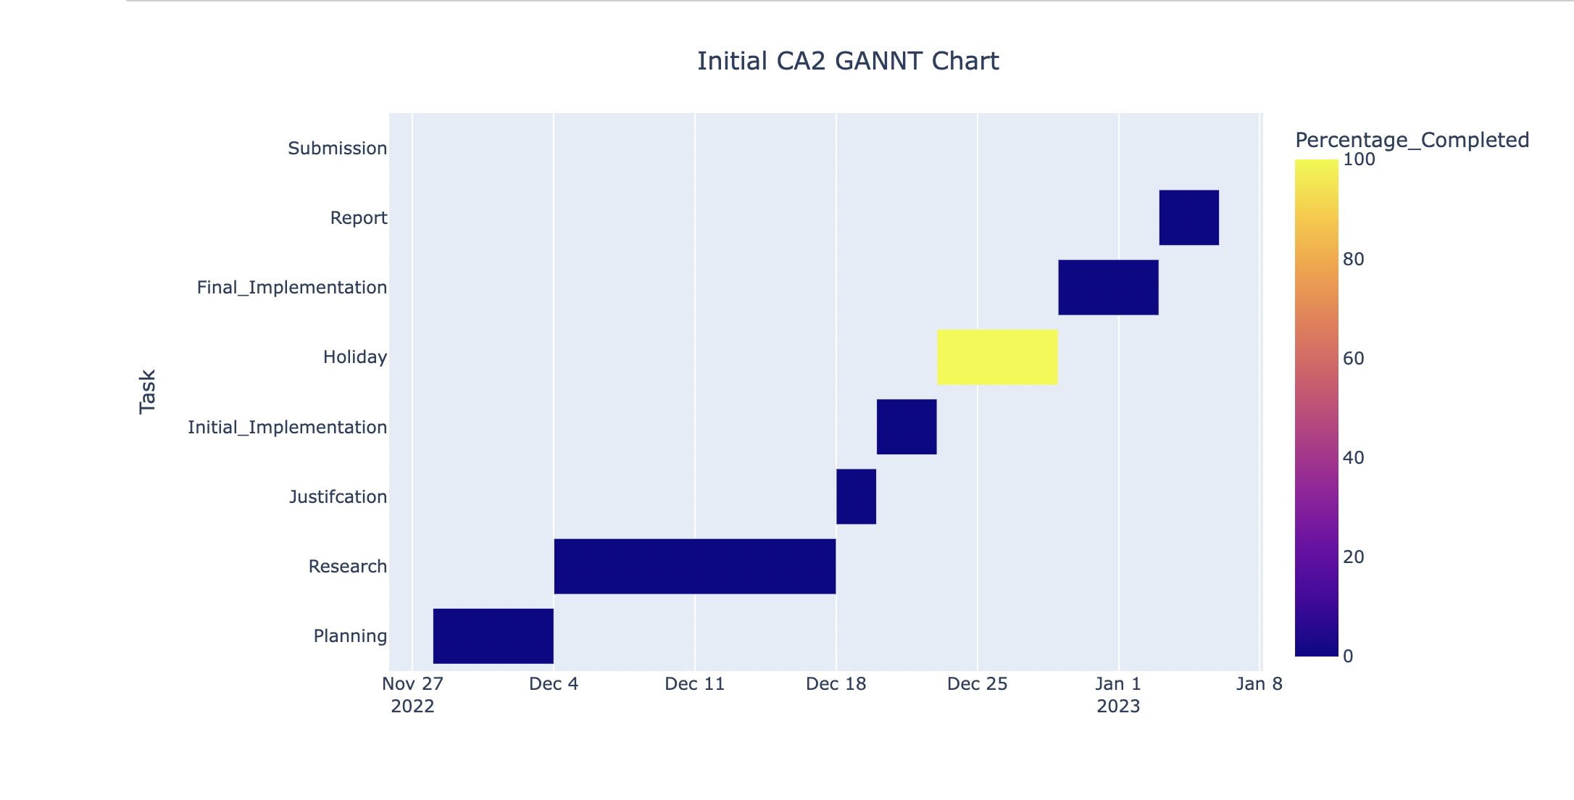

Figure 2 - Initial GANNT Chart

The chart above ( Figure2 ) shows the proposed timeline to complete all sections of the brief. Looking back on the deadlines and schedule I proposed I should have started this project work earlier. However, having this mapped from the start of the project was a huge benefit to see what was taking longer than expected.

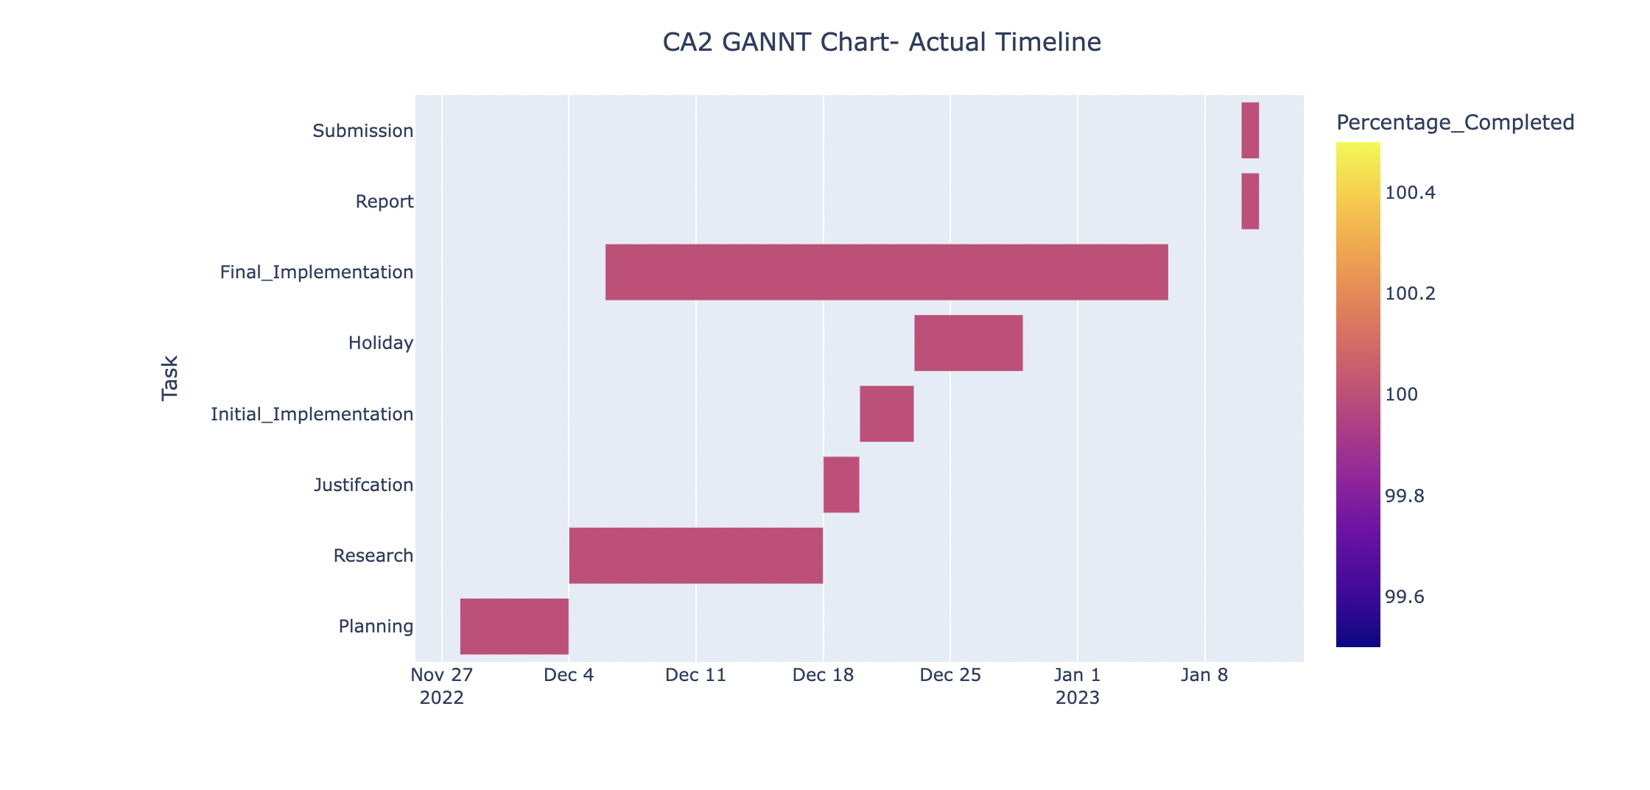

Figure 3 - Final GANNT Chart

The GANNT Chart above in (Figure 3) shows the final implementation. I used a colour coded completed timeline using the Matplotlib library, using the timeline module. Overall I left this project too late to complete on time and meet all deadlines. In the future, I will use the same process but allow less time for planning and work on the EDA sooner in the project timeline.

**EDA ( Exploratory Data Analysis )**

All the data was gathered and sourced from the Eurostat website. Its licensing information is available here. (Licensing, 2023)

Here it states that all data is free re-use for non-commercial and commercial

The pairlpots for my data show no real abnormalities or outliers in my data.

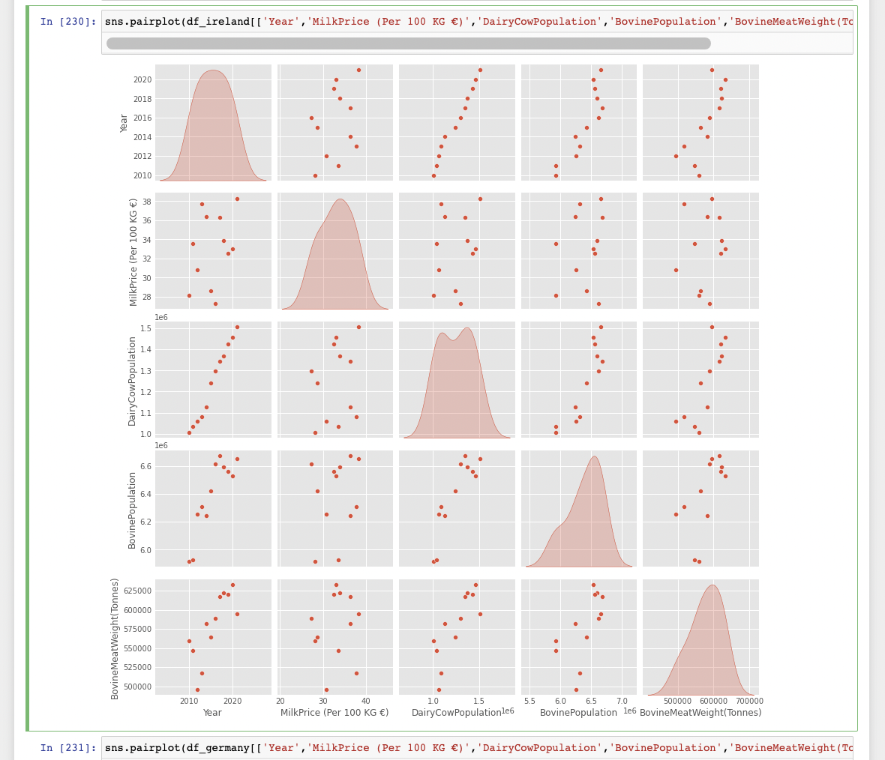

Ran out of time to complete the analysis on this section. All actions and decisions undertake in. the EDA stage should be in the DataPrepAndViz.pynb attached

**Statistics**

This section discusses the work completed in the Stats.ipynb file which is attached to this submission.

Firstly I imported the datasets that were prepared in the EDA section of this project. These datasets were imported using the pd.read_csv module of the pandas library. These datasets were Dairy and Bovine data from Ireland, our main focus of the analysis, and Germany and Spain.

Firstly I checked on the basic statistical stats of the datasets to get a feel for what the data looked like from a statistical point of view. Using the .describe function form the Pandas library, we can see the count, mean, standard deviation, min and max values , and the 1st, 2nd and 3rd quartile data of the datasets.

To get an idea of the distribution of these data frames, I create some histograms using the matplotlib libabry. I have attached some below for reference. I checked the all 3 datasets, and created the plots on the four columns of intertest, DairyCowPopulation, MilkPrice, BovineCowPopulation and BovineMeatWeight.

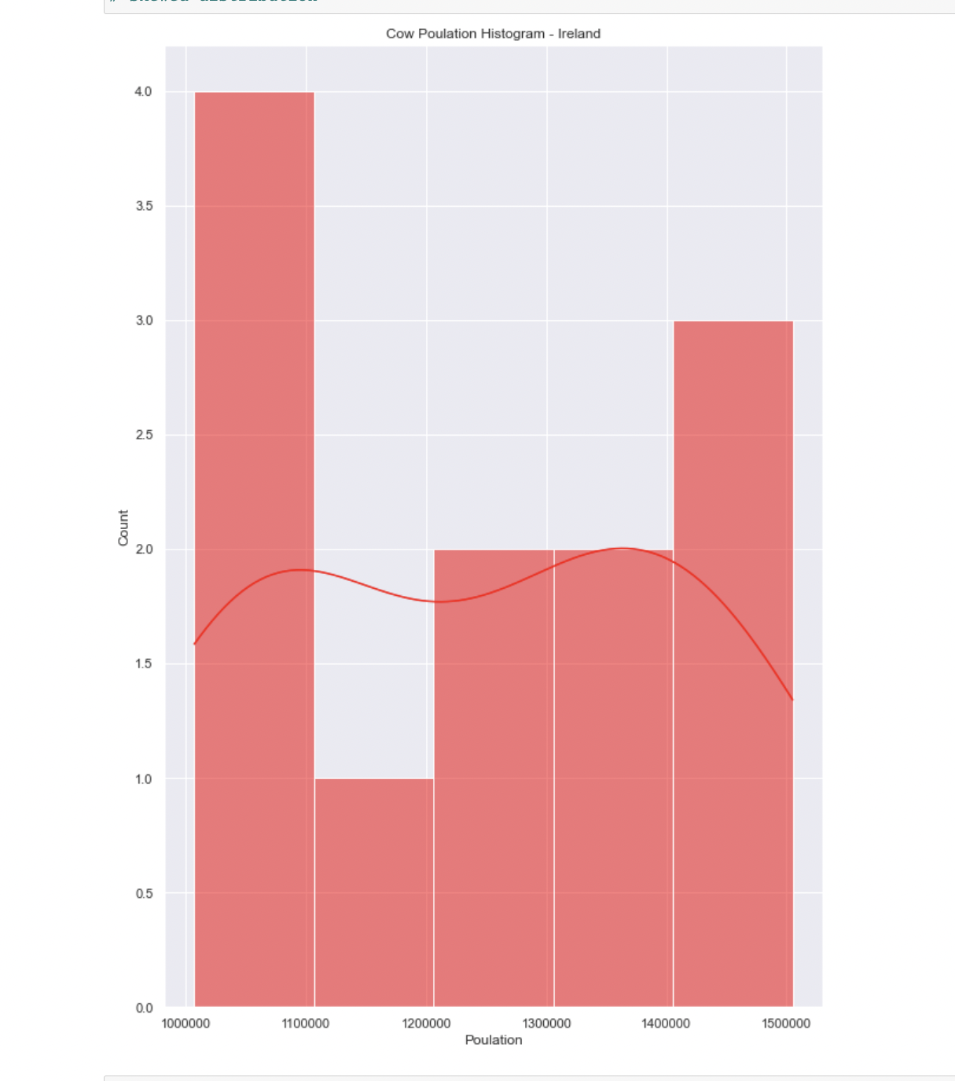 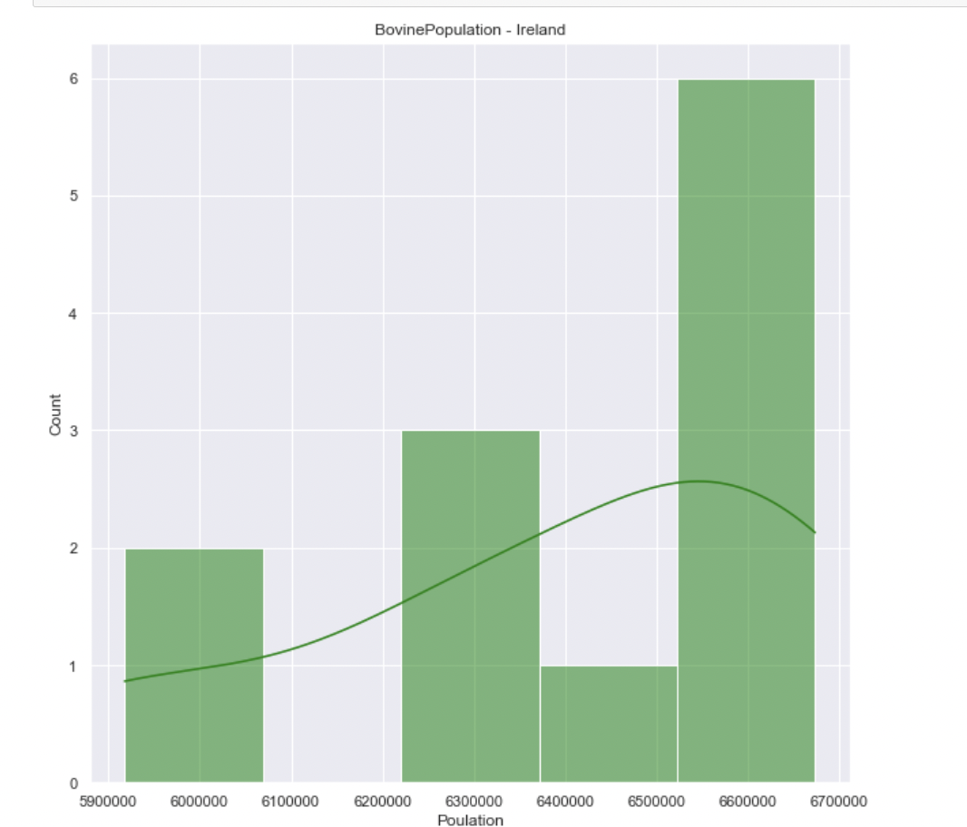

Figure 4 - Historgrams - Normality Test

From my investigations the majority of the data followed a normal distribution. To test these assumptions, I decided to undertake the tests below to confirm.

**Sharipo-Wilk Tests**

Sharipo-Wilk tests for normaliltiy. The test will reject the hypothesis , being normality, when the p-value is less than or equal to .05 or ( 95% confidence interval ).

I carried these tests out on all 3 datasets and all columns of interest, , DairyCowPopulation, MilkPrice, BovineCowPopulation and BovineMeatWeight. Alongside the histograms these tests can be used to test for normality.

To carry out these tests I created a test specific dataset called df_’Country’_shar_wilk_test. I created this for the 3 countrys of interest.

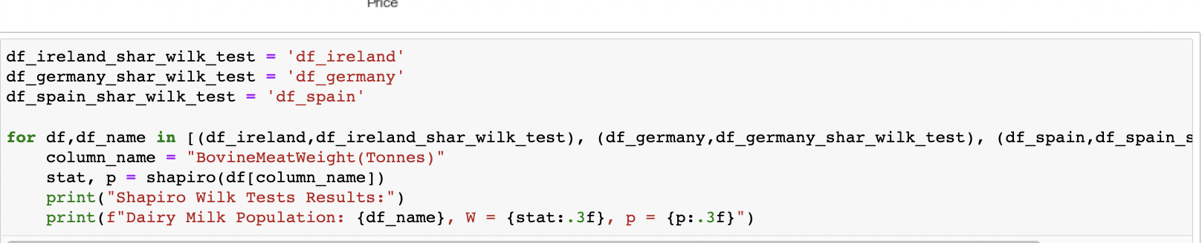

I used a for loop to loop through the three newly created dataframes and used the stats.sharipo library to calculate the results for each column in the dataset. I then printed out the results for each test, labelling each one individually for eeach country, passing it the variable ‘df_name’. This worked quiet well and I was able to create a table of the results to verify my normality eye tests from the histograms above.

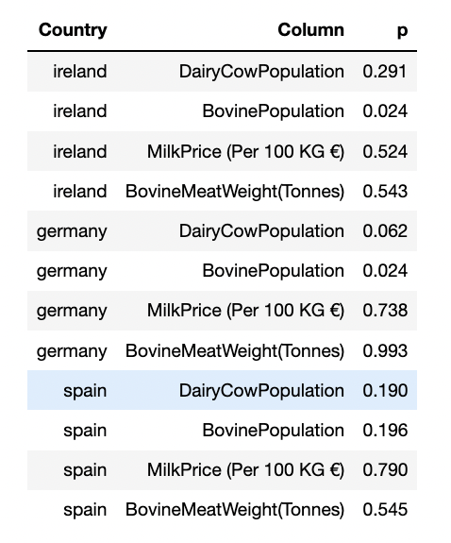

Figure 5 - Sharipo Wilks Tests

The above is the results of the Sharipo tests carried out. As the sharipo test states, any p value less than or equal to 0.05 proves that normality .

These are , ‘Ireland – BovinePopulation’ and ‘Germany – BovinePopulation’ , therefore, I can reject the null hypothesis for these 2 columns.

There is a 0.024 or 2.4% chance that these 2 columns data are normally distributed.

However, the rest of the columns all contain p values > 0.05 so we can assume these are somewhat normally distributed and accept the null hypothesis for the majority

**Confidence Intervals**

I created a function to calculate the confidence intervals of all the columns in the 3 datasets. I used a 95% confidence interval for all tests, while using the scipy package for stats, and imported the interval module to calculate this.

This test calculates the mean and margin of error and I printed both values out at the end of each countries and column tests.

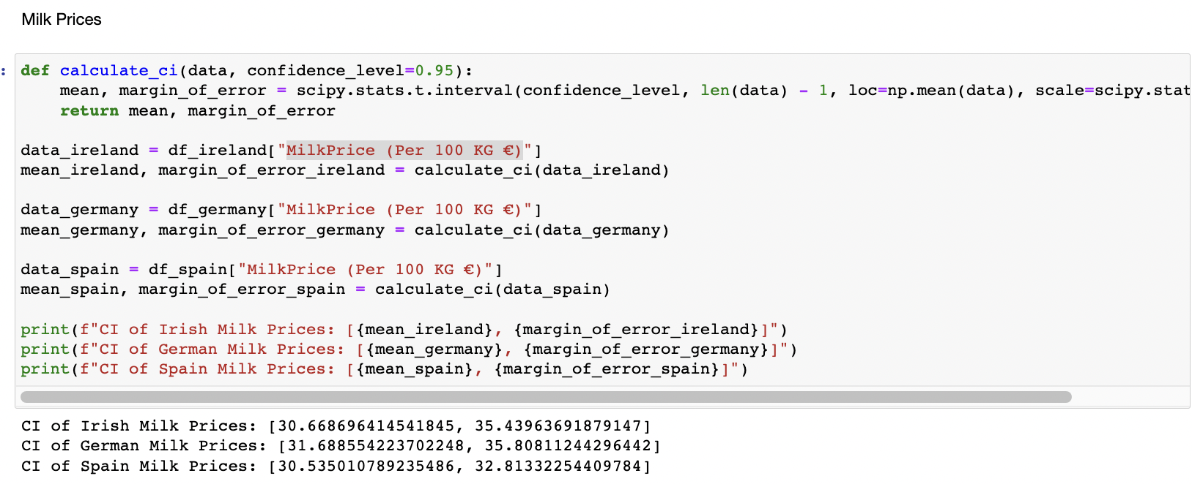

Figure 6 - Confidence Interval Tests

For all the results the mean was slightly lower than the actual mean calculated previously, while the margin of error is slightly higher than the real mean. This can be said to be due to the small population size of my data as the data is from only a 20 year period.

From this, we could derive at 95% confidence that the true populations for our data was between 2 distinct value the mean and the margin of error.

**T Test**

This test was carried out using the ttest library which I imported as part of the scipy package. This test required 2 datasets to run, so I chose Ireland and Germany’s Milk and Dairy columns for this analysis.

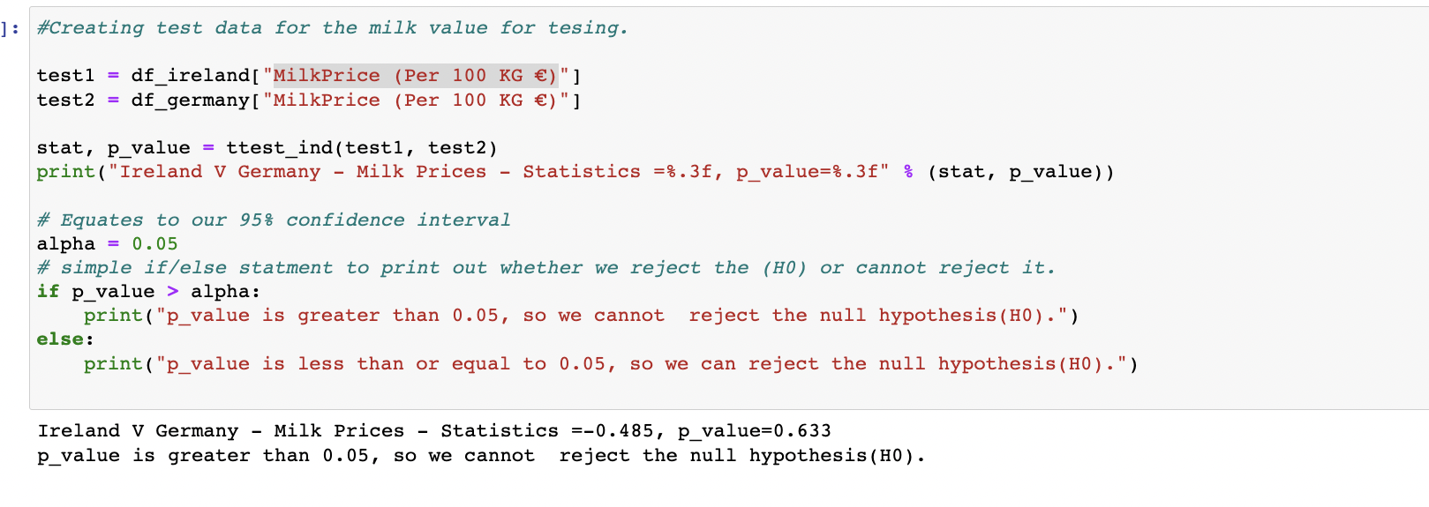

Figure 7 - T Test

The test results showed that the p-value was greater than or equal to 0.05 therefore I could not reject the null hypothesis (H0)

**Wilcoxon test**

This test was carried out using the wilcoxon library which I imported as part of the scipy package. This test required 2 datasets to run, so I chose Ireland and Germany’s Milk and Dairy columns for this analysis.

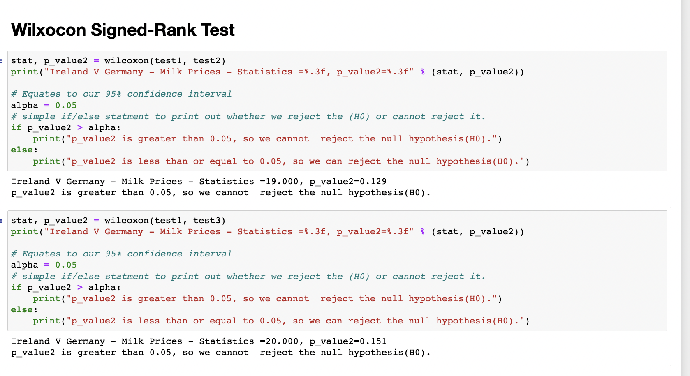

Figure 8 - Wilcoxon Test

The test results showed that the p-value was greater than or equal to 0.05 therefore I could not reject the null hypothesis (H0)

**Friedman Test**

This test was carried out using the freidmanchisquare library which I imported as part of the scipy package. This test required 2 datasets to run, so I chose Ireland and Germany’s Milk and Dairy columns for this analysis.

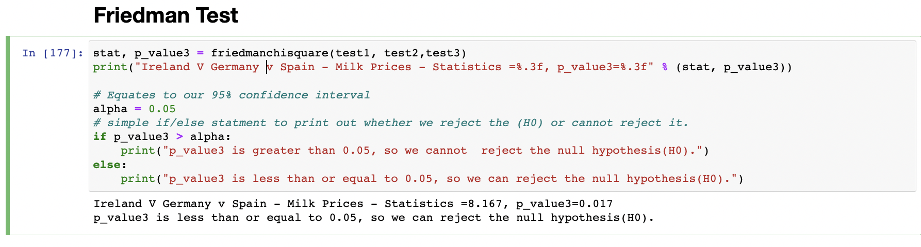

Figure 9 - Friedman Test

Again, The test results showed that the p-value was greater than or equal to 0.05 therefore I could not reject the null hypothesis (H0)

**Kruskal-Wallis H test**

This test was carried out using the Kruskal library which I imported as part of the scipy package. This test required 2 datasets to run, and I chose Irleands Dairy columns, which were DairycowPopulation and MilkPrices.

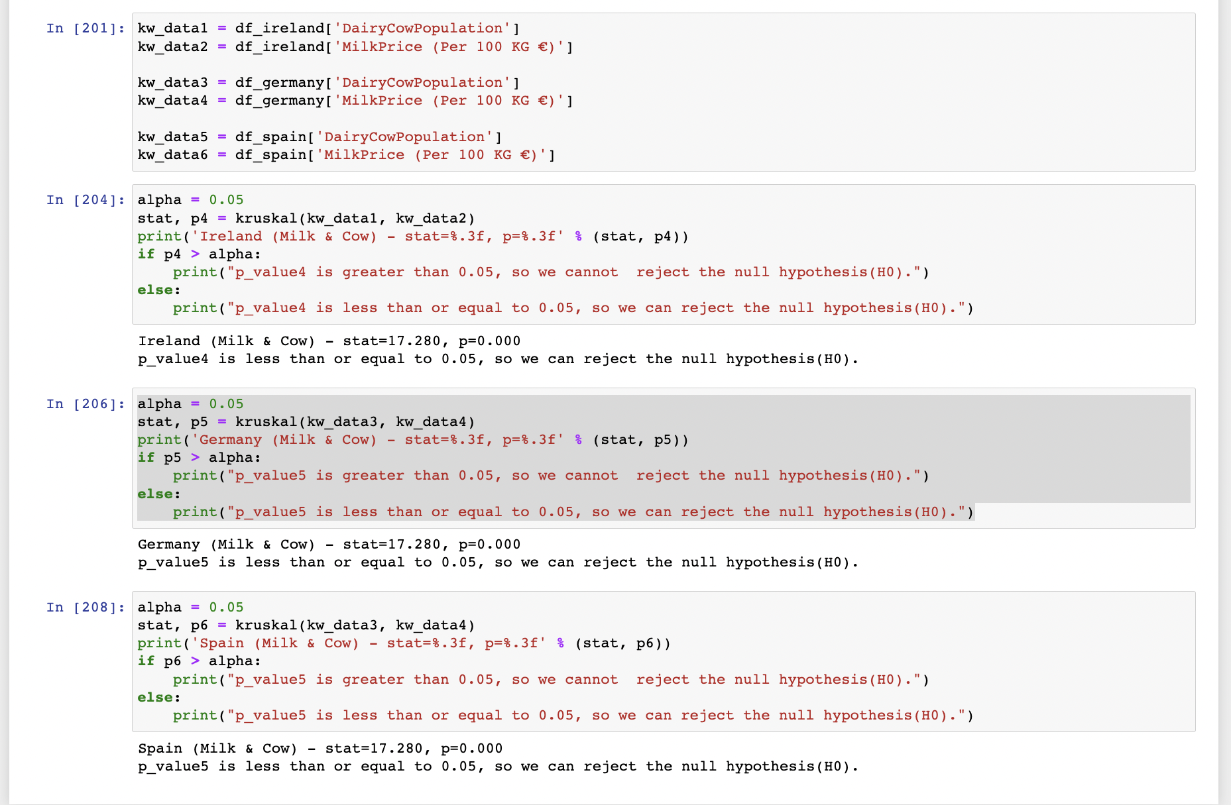

Figure 10 - Kruskal Test

Finally. The test results showed that the p-value was less than or equal to 0.05 therefore we reject the null hypothesis (H0)

**Machine Learning**

Unfortunately I ran out of time for this part of the report.

**Plots**

I plotted some simple correlation plots to check for correlation between the dataframe columns.

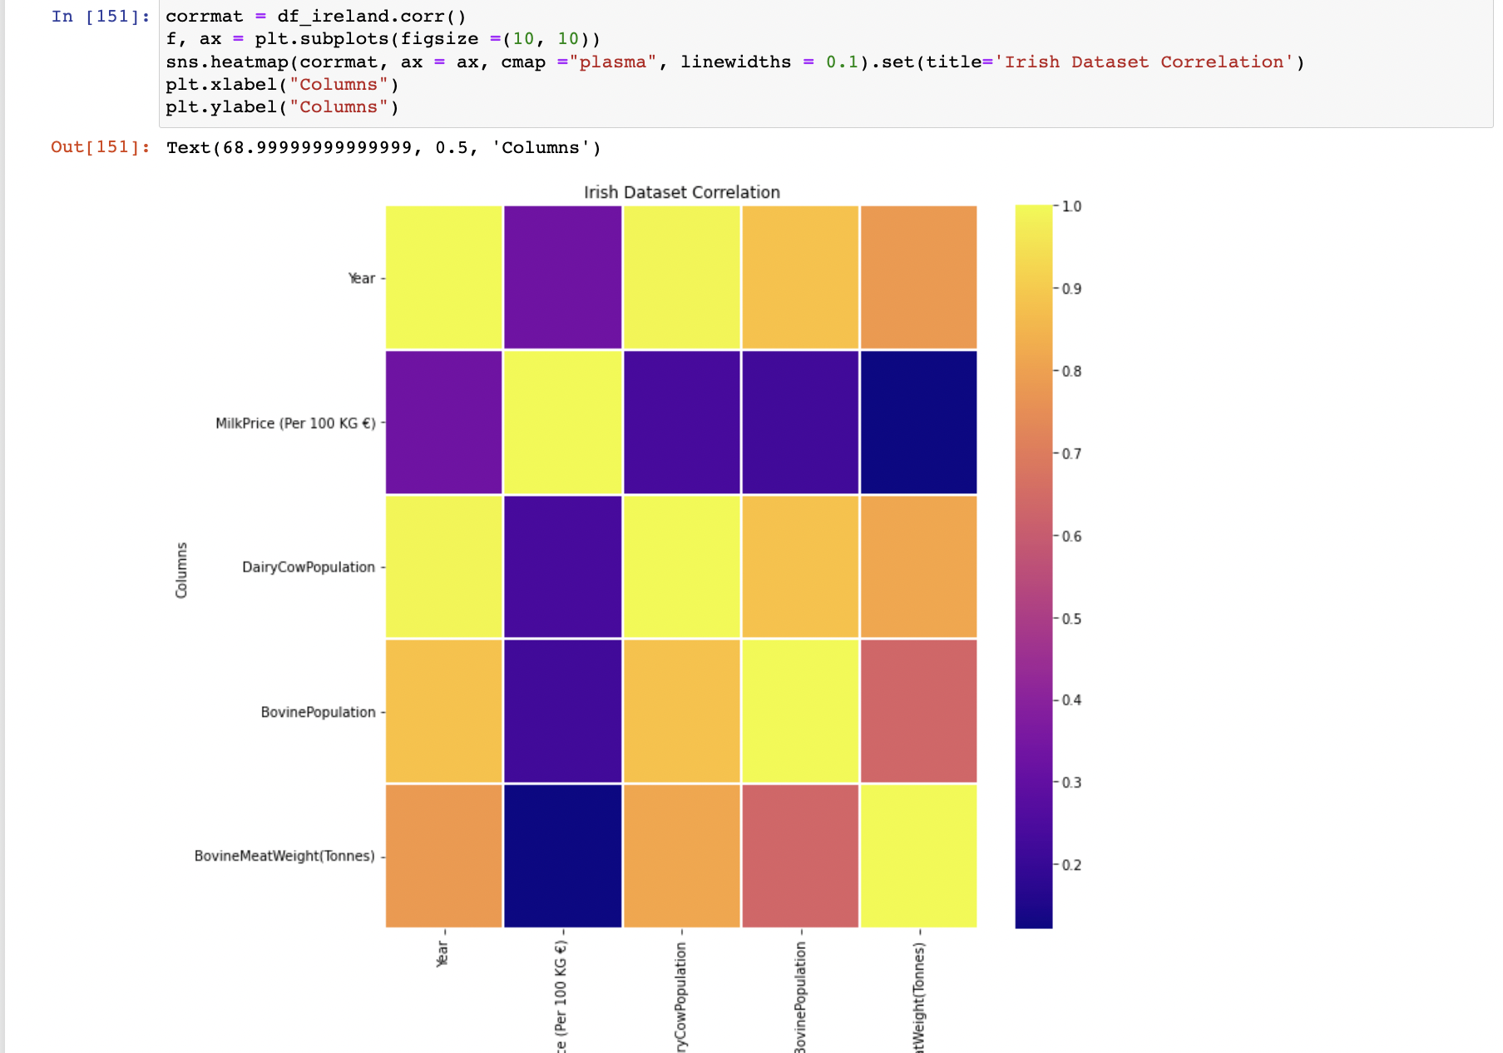

**Lazypredict**

To check what Classification algorithim to use I imported the lazypredict package to attempt to identify what classification models to use.

I created two target variables , MilkIncrease and WeightIncrease and assigned 1 to the dataframe if the value was above the mean average and 0 if it was below the mean average

The results showed a result of 100% or 1.0 for many of the classification models.

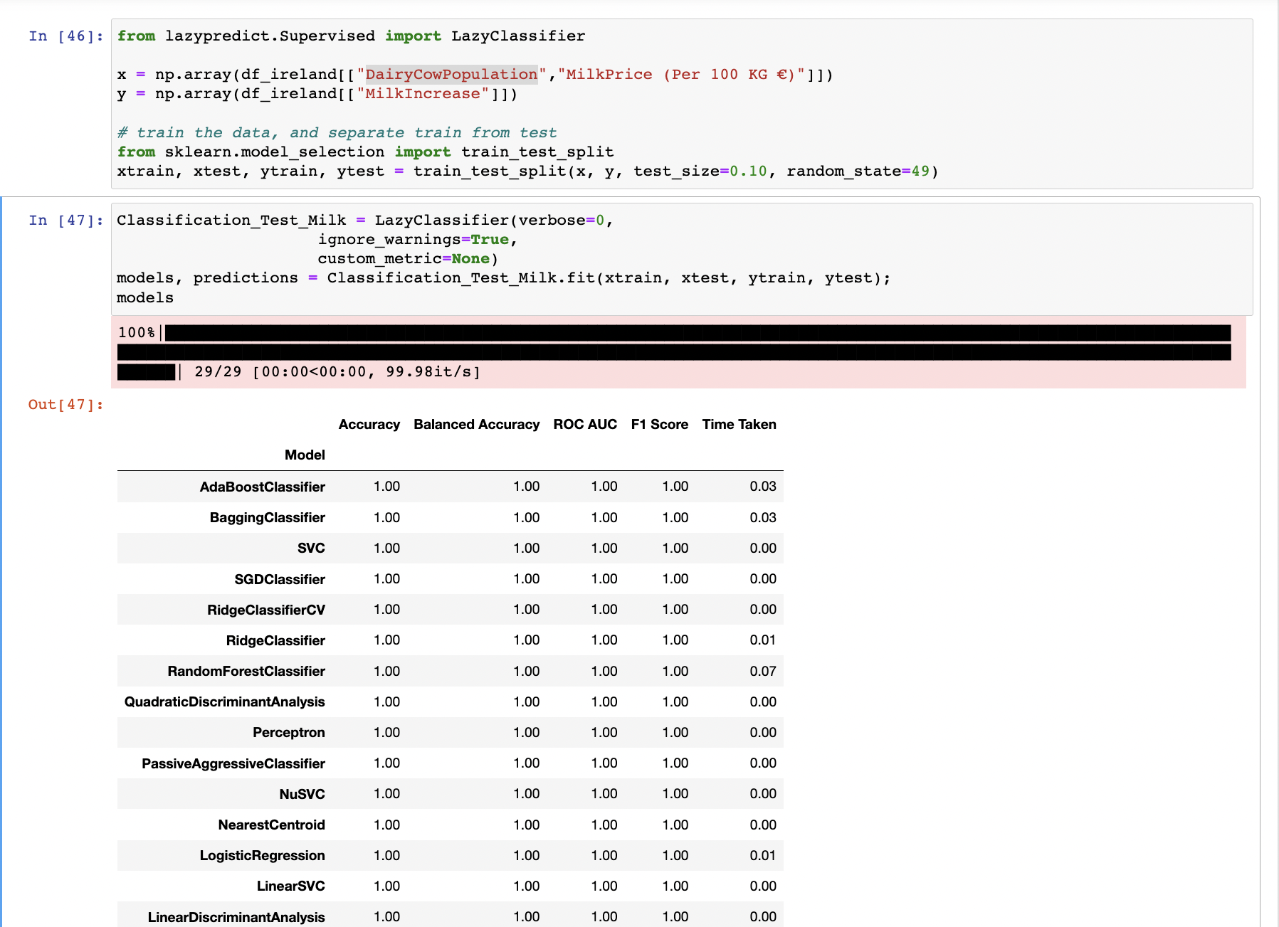

**Linear Regression**

**NearestNeighbours**

**Sentiment Analysis**

Incomplete

**Results**

The results did not work as expected.

**Random Forest**

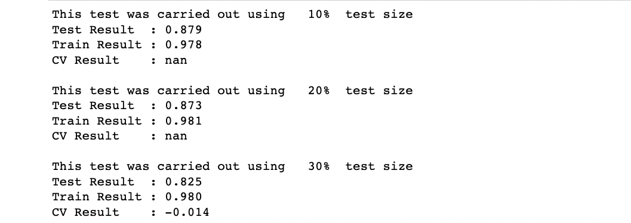

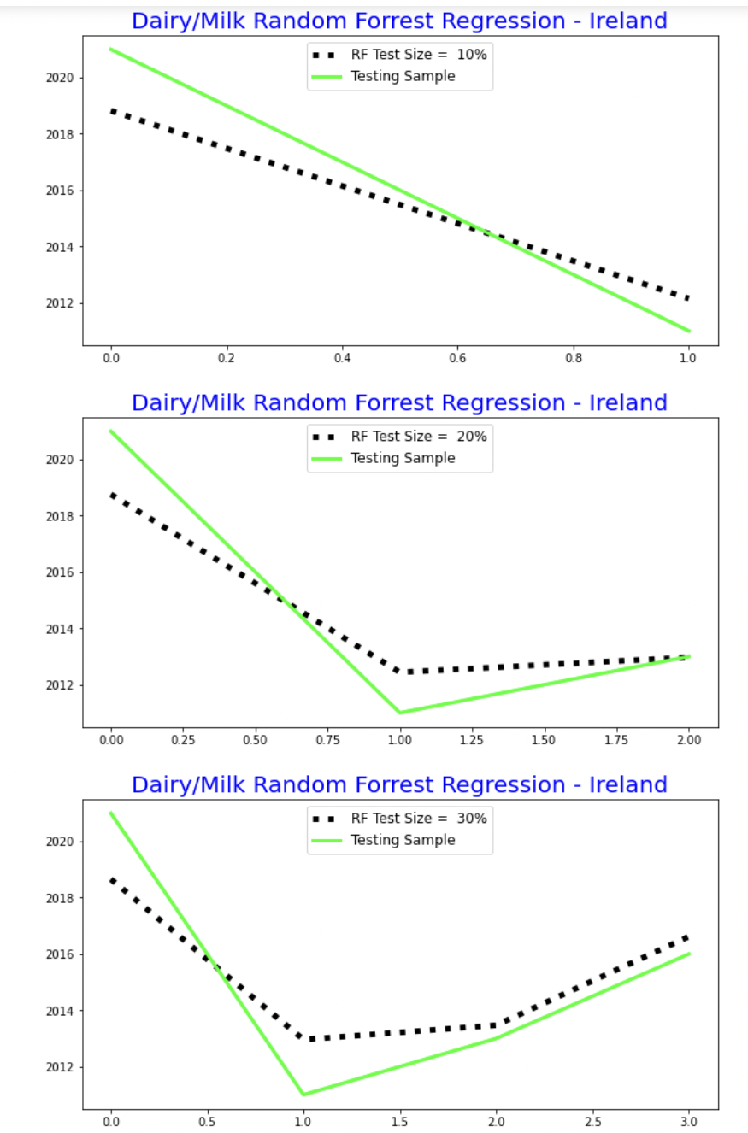

**Linear Regression**

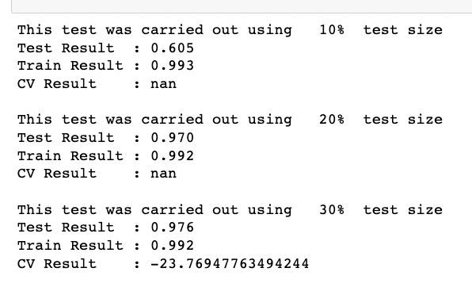

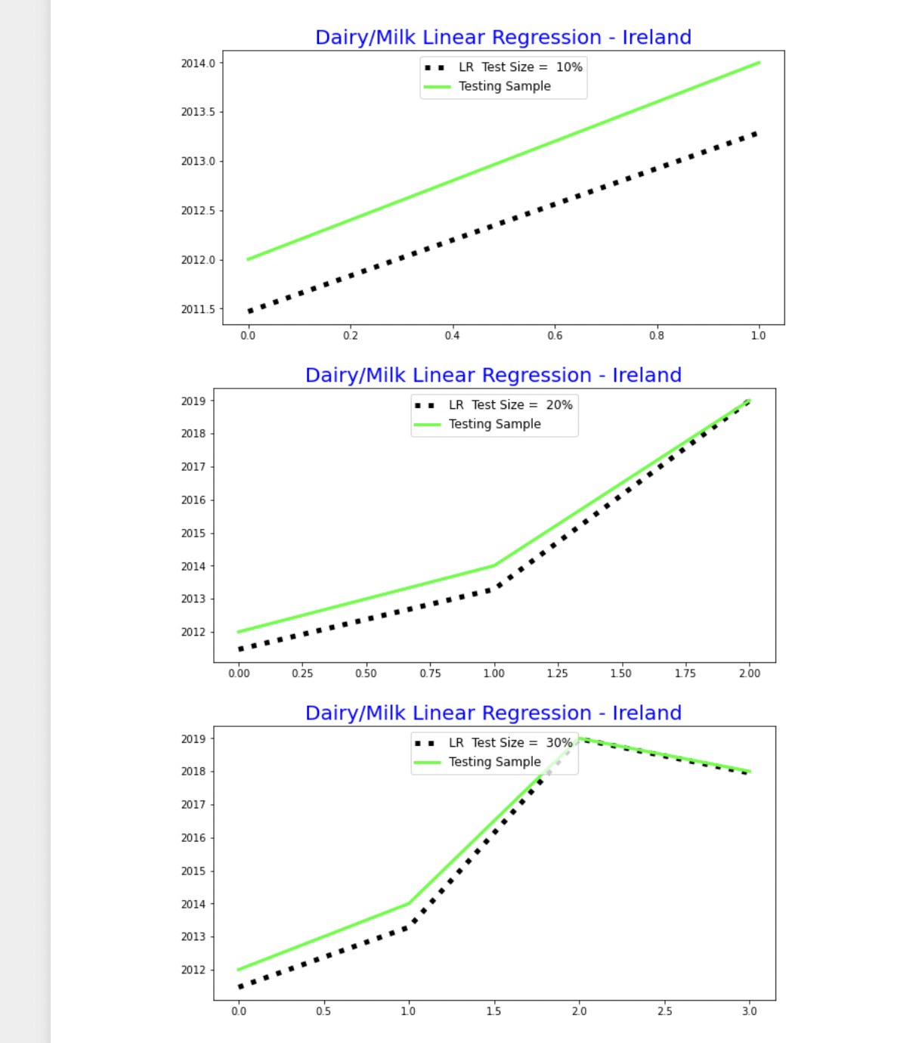

**Discussion/Conclusions**

* This project report was incomplete. This is due to running out of time during the project. I will plan and allocate more time for future CA’s
* My Datasets were too small to perform much forecasting and Machine Learning on.
* For EDA, this went well, although the report may be incomplete, the work undertaken allowed the data to become readable and usable in the stats and ML Section
* In the EDA, many good functions and data exploration technqiues worked well
* For Stats the tests worked and I was able to figure out many descriptive and inferential statistics on the data

# Bibliography

Brock, J., 2022. *Irish Veterinary Journal.* [Online]   
Available at: https://irishvetjournal.biomedcentral.com/articles/10.1186/s13620-022-00212-x

Eurostat, 2023. *Eurostat.* [Online]   
Available at: https://ec.europa.eu/eurostat/data/web-services

Wikipedia, 2022. *https://en.wikipedia.org/wiki/GitHub.* [Online].

**Table of Figures**

Figure 1- Git Example 4

Figure 2 - Initial GANNT Chart 5

Figure 3 - Final GANNT Chart 6

Figure 4 - Historgrams - Normality Test 8

Figure 5 - Sharipo Wilks Tests 9

Figure 6 - Confidence Interval Tests 10

Figure 7 - T Test 11